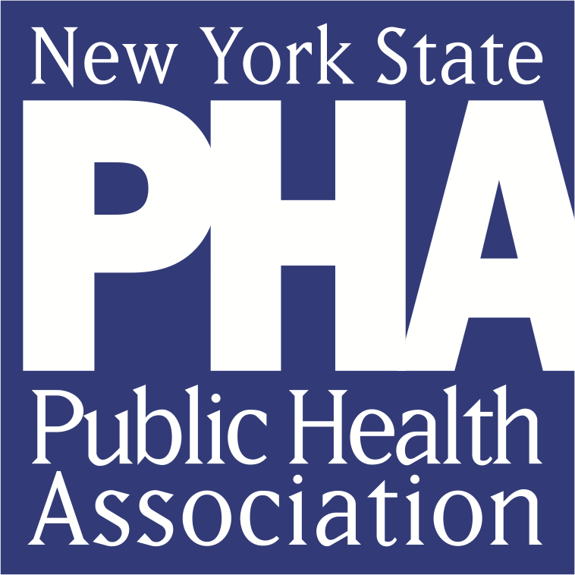

NYSPHA Internship Application

In order to be considered for an internship, you must submit a signed and completed application form along with a cover letter and your resume. Incomplete applications may not be reviewed.

Date of application: _________________________

Name:__________________________________________________________________

College/University:________________________________________________________

Student Email Address:____________________________________________________

Student Mailing Address: ________________________________________________________________________

________________________________________________________________________

Student Telephone Number:_________________________________________________

Name & Title of Advisor or referring professor:
________________________________________________________________________

________________________________________________________________________

Advisor Email & Telephone Number: ________________________________________________________________________

Are you requesting that your college grant you credit hours for your internship?________

Semester available to intern (check all that apply:
____Spring Year_____
____Summer Year_____
____ Fall Year ____
____ Temporary Conference intern Year _____

Dates available to perform internship:_____________________________________

Total number of internship hours requested: ___________________________

Please indicate which internship you would like to be considered for. You may select more than one:
Public Health Event Planning & Communication Intern

Policy & Advocacy Intern

Membership & Communication Intern

Poster Session Organizer (Spring semester only)

Event Accessibility Organizer (Spring semester only)

Event Logistics Coordinator (Spring semester only)

Continuing Education Coordinator (Spring semester only)

References:
1 2 3
Name
Relationship
Title
Telephone Number

………………………………………………………………………………………………
Why would you like to work for NYSPHA as an intern? ________________________________________________________________________________________________________________________________________________________________________________________________________________________________________________________________________________________________________________________________________________________________________

I certify that the statements in this application are true and complete to the best of my knowledge. I understand that a false or incomplete answer may be grounds for not considering me or for my dismissal.

Signature__________________________________________________

Date______________________________________________________

Please submit completed application with a cover letter and resume to:
Erin Sinisgalli, Executive Director, at info@nyspha.org.

For questions on this application, please contact us at info@nyspha.org.

