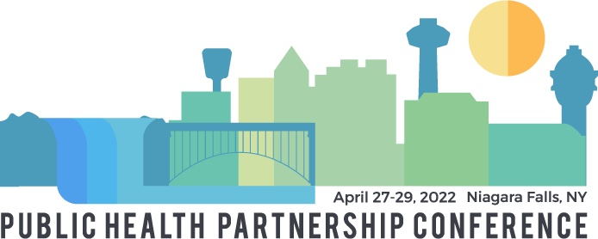

Public Health Partnership Conference
Infection Control Protocol

The hosts of the 2022 Public Health Partnership Conference are committed to providing a safe and healthy environment for all conference participants. Our decisions and preventive measures will be guided by the requirements and recommendations of the Centers for Disease Control (CDC), and federal, state, and local health authorities. We are working with the Niagara Falls Convention Center staff to implement preventive measures to protect all attendees and reduce the potential spread of the COVID-19 virus at the Conference. Infection Control Protocol will include (subject to change):

- Social distancing, hand sanitizer, masks and other safety guidance signage will be in place throughout the event.

- Per NYS/CDC Recommendations:
  - Confirmation of up-to-date vaccination status (i.e. full series plus booster) via CDC vaccine card and/or Excelsior Pass will be required at check-in.
  - If an attendee has a valid medical exemption, proof of exemption plus a negative PCR test within 72 hours of event will be required at check-in.
  - Masks are required for all individuals regardless of vaccination status unless participants are eating/drinking.

- Screening Prior to Event:
    - All in-person attendees will be encouraged to take PCR or Rapid test within 72 hours of arrival to event.
    - All attendees will complete a daily screening check.
    - Participants must follow the CDC guidance for small and large gatherings if you have been exposed or have been experiencing symptoms of covid. Please review these recommendations prior to your arrival at the event: Small and Large Gatherings | CDC

    - An exception to the cancellation policy will be made for individuals who (1) have been recently exposed to covid-19 (2) are experiencing covid-19 symptoms and are in isolation or (3) have had a positive covid-19 test in accordance with CDC recommendations, and their registration transferred to virtual attendance.

- Attendees will be able to visually identify their comfort level with designations of red ribbons for No Contact.

- Hand Hygiene and Respiratory Etiquette:
    - Require frequent staff and participant handwashing with soap and water for at least 20 seconds.
    - Hand sanitizer that contains at least 60% alcohol will be made available to all participants.
    - Encourage staff and attendees to cover their coughs and sneezes with a tissue (dispose in trash and wash hands).
    - Discourage handshakes, high-fives and fist bumps to avoid contact and display signs and posters that reinforce this guidance.
- Additional cleaning and disinfection protocols will be in place:
    - Shared spaces and high touch objects will be cleaned and/or wiped down between use.
    - Bathrooms will be cleaned based on an enhanced cleaning schedule more often than required by law. Disinfecting wipes will be placed in the venue bathrooms.
- Ventilation:
    - Weather depending, doors/windows to the event will be opened during conference.
- Food & Beverage:
    - Buffet meals will be served by masked servers during the event. A sneeze guard will be located between the guests and the food.
    - Boxed lunches will be served on day two at the conclusion of the conference.
In-person conference attendees should self-monitor for signs and symptoms of COVID-19 during the conference and are asked to contact event hosts at info@nyspha.org if they experience symptoms within 10 days after the conference. Should any positive cases be reported within the 10-day time frame, event hosts will communicate this information to all registered participants. Any private health or personal data received by event hosts will be treated as confidential.

Thank you to Niagara County Department of Health, which has offered to provide rapid, self-administered covid-19 test kits to conference participants in the event they should be needed or requested by participants during the event.

**All Public Health Partnership Conference policies are subject to change. Should changes be made, a notification will be sent to all registered attendees.

